Name of Technology: IBM Watson

What is it?

Build cognitive apps that help enhance, scale, and accelerate human expertise.

<http://www.ibm.com/smarterplanet/us/en/ibmwatson/what-is-watson.html>

What does it do?

Build cognitive apps that help enhance, scale, and accelerate human expertise.

Navigate through multi structured data including text, images and video to generate actionable insights from "Dark Data" – data that is not machine readable, not easily accessible, or not leveraged.

An insight serves to augment the knowledge, perception, and awareness of the end user, with the goal of improving their efficiency, decisions, and ability to quickly react to emerging scenarios.

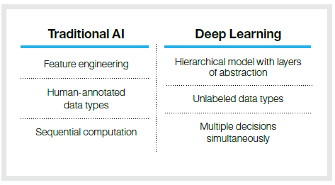

What are the features?

**Mimic Humans**

* Natural Language Classifier
* Corpus of Knowledge: curating the content, ingestion, cognitive assistance, scalable transition
* Learn the language: jargon, standard of core practices
* Motive thought
* Automated customer service: using Watson Engagement Advisor

**Technology meets human intuition**

Watson has a unique capability to literally think and get smarter the more questions it answers. Watson will be a key destination for student questions and answers, all in real time.

**Watson communicates like us**

Understanding and providing answers in natural language breaks down barriers, and means students don’t need to know all the right words.

**Watson is clear and confident**

Watson weighs up material to determine the best answer, but can also direct students to an exact person who can assist.

**Watson is always learning**

Just like us, Watson continually learns and improves answers. Working together with IBM, Deakin is creating a more personalised experience for our students.

Is the technology academic or student driven?

Both, however mainly academic.

Academics could use this technology as a teaching resource to increase student knowledge and improve their skills. The main advantage would be to have a better search experience and reduced work load.

Students could use the technology to find what they want in the first place rather than looking out for different options for general and advanced assistance.

<http://ibmwatson.deakin.edu.au/?cm_mc_uid=82224045575814216756932&cm_mc_sid_50200000>=

What is its purpose?

To create an engaging ……….

What does it offer the students?

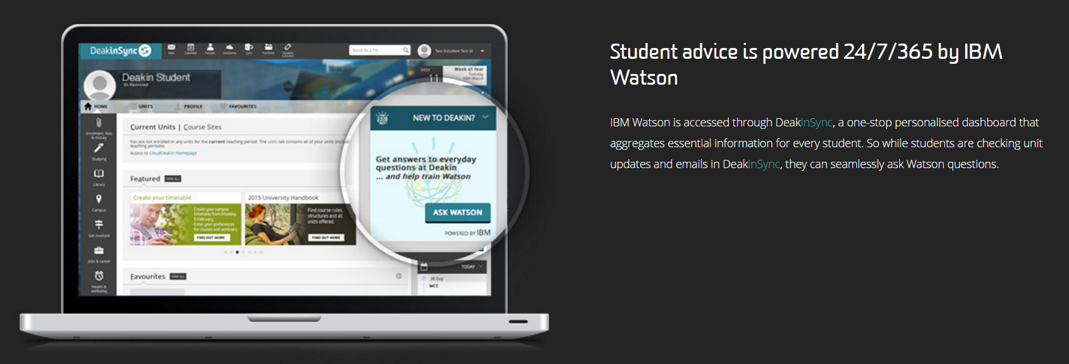

What does it offer to academic?

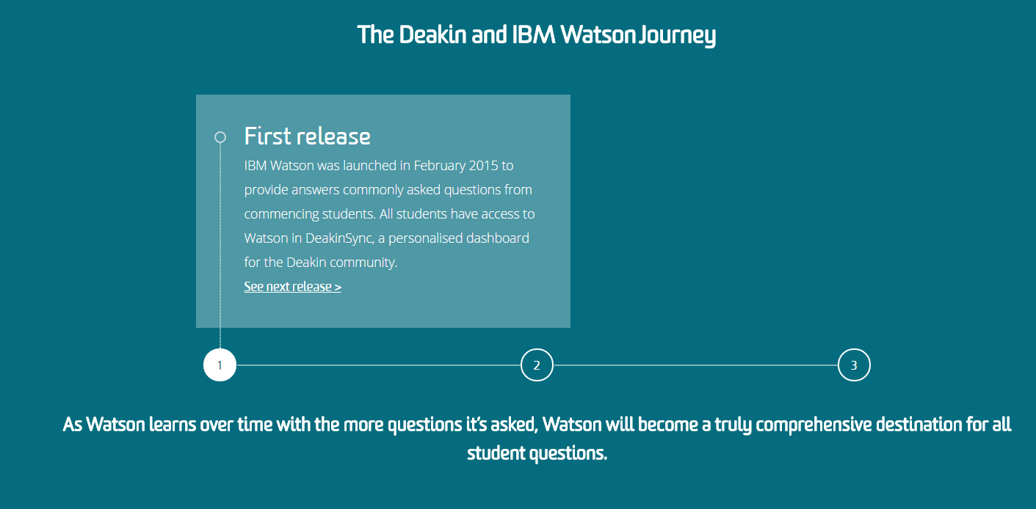

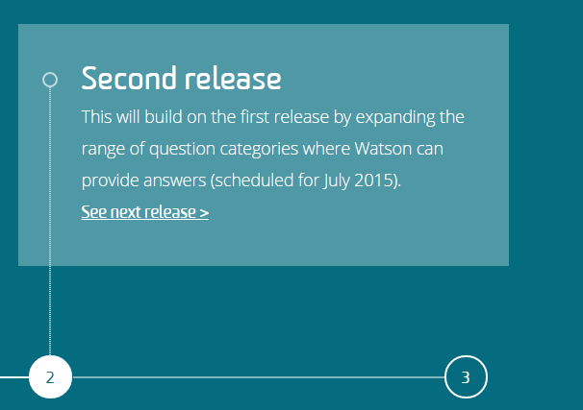

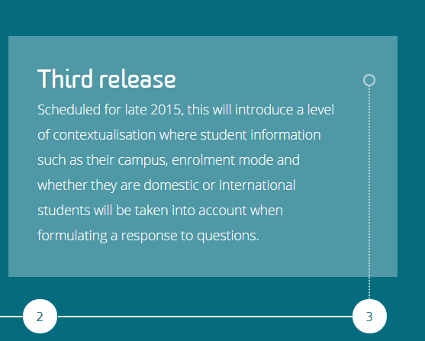

How will it enhance student learning?

Personality characteristics such as neuroticism and conscientiousness can negatively and positively indicate academic performance. Openness and conscientiousness often lead to more self-improvement learning, while neuroticism (emotional range) decreases such motivation.

<http://www.ibm.com/smarterplanet/us/en/ibmwatson/developercloud/doc/personality-insights/basics.shtml#overviewApply>

<http://www.pwc.com/us/en/technology-forecast/2012/issue1/features/feature-mining-social-media-intelligence.html>

Are there any reviews online about this technology?

Yes – more on the medical side. The few I could find more a learning and teaching perspective are as

<https://www.linkedin.com/pulse/ibm-watson-analytics-short-review-peter-dorrington>

<https://www.betterbuys.com/bi/reviews/ibm-watson-analytics/>

<http://www.datamensional.com/5-things-you-need-to-know-about-ibms-watson-analytics/>

<https://www.linkedin.com/pulse/ibm-watson-education-future-studying-john-hanks>

How hard is it to set up for the academic?

Would require 30 to 60 …………..

How hard is it to set up for student?

Would require 30 to 60 ………….

**Does the technology work for students who are on campus and those studying at a** distance?

Potentially yes but only if the software/hardware requirements are met in order to be able to use it effectively.

What will they need in terms of computer/tablet etc. to use the technology?

* Any mobile device

Has anyone done trial on it? Is there any experimental data anywhere? What did the students think of it?

The University of Adelaide are currently running a Virtual Reality Pilot Project which may had

<https://www.ibm.com/blogs/watson/2016/05/cognitive-systems-will-make-personalized-learning-reality/>

Does the technology fit in with particular subject area more than others?

This technology could be used in a number of subject areas such as; medicine, health science, design, engineering, education, history and earth sciences.

<http://australia.nuance.com/for-business/index.htm>

What is required from the students to set up?

A PC computer with the stated system requirements. Also, would require 30 to 60 minutes and a safe space to be set up.

Privacy: Do they need to give their email address? Gmail account etc.?

If so, where is the information stored and what is done with it?

The set up information …………

**Institutional/stakeholder risk: Is there any risks associated with using this technology to** the institution or individual? If so, what?

If not set up and ………….

What are its measures of success?

* Student participation and feedback
* Cost savings of resources replaced by Technology i.e. resources accessible at single clink
* User experience

<http://blog.operasolutions.com/how-natural-language-processing-can-improve-spend-analytics>

What are the costs of using this technology? From a small trial perspective (approx.. 5 pax)

<https://console.ng.bluemix.net/pricing/>

What support would need to be given during a trial?

* Technical support to set up IBM Watson properly.
* Technical support to show academics, staff and students how to use IBM Watson.

Are there any USQ core-supported technologies that are similar?

Yes, Splunk – USQ Security uses it to track user data and server logs etc.

Any security risks?

Information to create user profile and history would be stored on the providers’ server.

How does this technology work with students who have disabilities, such as auditory (hearing/vision) or those with language difficulties

There would be some accessibility issues with users who have disability as they would not be able to use this type of Technology to its full potential.

**Other Notes:**

**Personality Insights**

The Personality Insights service uses linguistic analytics to infer cognitive and social characteristics, including Big Five, Values, and Needs, from communications that the user makes available, such as email, text messages, tweets, forum posts, and more. By deriving cognitive and social preferences, the service helps users to understand, connect to, and communicate with other people on a more personalized level.

<https://console.ng.bluemix.net/docs/services/PersonalityInsights/index.html#gettingstarted>

References:

***Please refer below GitHub link for all the reference files and if you come across anything interesting, please feel free to upload and comment on this repository. Thank you.***

<https://github.com/Vinit91/IBM-Watson>

<http://www.ibm.com/developerworks/cloud/library/cl-bluemixfoundry/>

<https://console.ng.bluemix.net/>

<https://console.ng.bluemix.net/catalog/>

<http://www.ibm.com/smarterplanet/us/en/ibmwatson/developercloud/>

<http://researcher.watson.ibm.com/researcher/view_group.php?id=4977>

<https://www.ibm.com/analytics/watson-analytics/us-en/by-industry/education>

<http://www.research.ibm.com/cognitive-computing/machine-learning-applications/decision-support-education.shtml#fbid=nmSHmjcDeMZ>

<http://www.crainsnewyork.com/article/20150212/TECHNOLOGY/150219948/ibm-wants-to-put-watson-in-hands-of-every-teacher>

<http://blog.mashape.com/list-of-25-natural-language-processing-apis/>

<http://techcrunch.com/tag/natural-language-processing/>

<http://www.dataversity.net/enterprises-time-to-dive-into-natural-language-applications/>

<http://www.cio.com/article/2843710/big-data/10-ibm-watson-powered-apps-that-are-changing-our-world.html>

***25/7/16: Compare with Splunk***

<http://www.dbms2.com/2012/08/24/hadoop-notes-informatica-splunk-and-ibm/>